|  |  |
| --- | --- |
| A picture of a winding road and trees  Ideal BOOK SHELF  Architectural Structural Design | Margi Shah (30105730)  Vineet Man Singh(30105923)  Nasser Alzuabi (30101848) |

Contents

3. Solution Architecture 2

4. Classes 3

5. Modules 4

6. Application Logic 5

a. Use Case diagrams 5

b. Use case descriptions 5

c. Sequence diagrams 6

d. Data Flow Diagram 12

7. Storyboard 12

8. User Interface design 18

References 19

# 3. Solution Architecture

Solution architecture is a design of a specific information system or applications that highlight the requirements and major components.

Ideal Book Shelf is a website where user can borrow and lend books, create a circle with different people in specific groups or lists which allow them to share relevant content. In order to use these services the user should register with website and be a member. Furthermore, user should write a description for items he/she want to lend, once the user added items the user can decide who can borrow his/her items . A circle (list of users) will be notified that books are ready to borrow, however others cannot borrow until they join and become a member of the website. Users can search for books they want to borrow from the search engine. Thus, if the user want to borrow an item there is a button call “borrow” next to it, as well as a remove button call “remove” next to the item want to obliterate.

# 4. Classes

Our website is called Ideal Book Shelf and its showing different classes like Register, Book, User, Circle, Lender and Borrower where lender, borrower and circles classes are child classes for the user class as showing in the above Class Diagram. The Classes are also showing different attributes and methods related to it.

Book

Title

Author

Publisher

Publication Date

User

User id

Circle

Circle Id

User Id

Borrower

User Id

Book Title

Register

User ID

User name

Password

Email

Postcode

Lander

User ID

Book Title

# 5. Modules

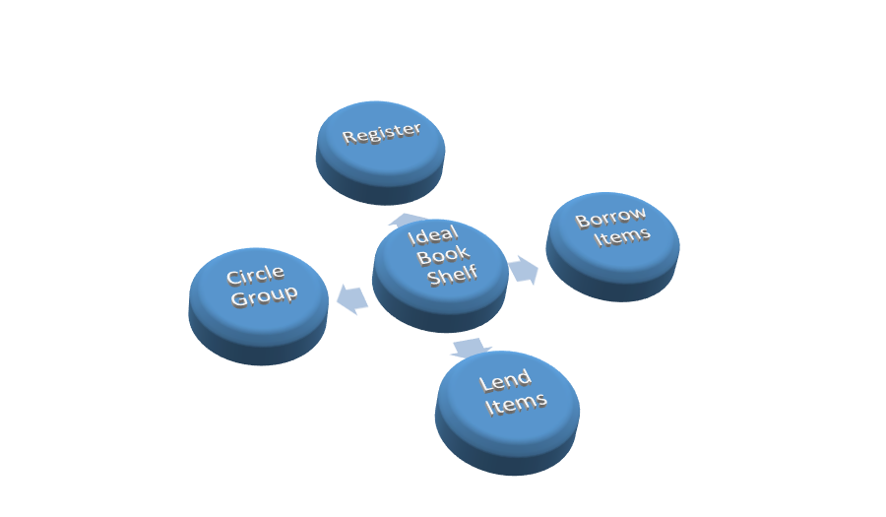

# 6. Application Logic

## a. Use Case diagrams

User (Lender) User (Borrower)

## b. Use case descriptions

**Registration**

A user can register into the system in order to lend or borrow.

**Login**

A user can login into the system after the user has registered. Onces the user logins a session is started.

**Session**

Borrowing and lending of book is done in a system when a session is started. Session starts after the user has logged in.

**Lender**

*Put item for borrowing*

A lender can put books for borrowing into the system. And the book is added to the database.

**Create a circle**

A lender can create a circle i.e. a group or category of people with whom certain books can be lend.

**Add user**

A lender can add user to a circle by searching for them with email address.

**Borrower**

**Join a circle**

A borrower can join a circle via lender’s permission

**Borrow item**

A borrower can borrow item’s that are listed by the lender in the system.

**Search item**

A borrower can search for items they want in the system.

## 

## c. Sequence diagrams

Registration



Login



Put Item for borrowing



Create a circle

Add user to circle



Join a circle



Borrow Item



Search Item



## d. Data Flow Diagram

Login User name &password

Database

Login right, user uses the services

If the login incorrect login again

Asking for approval to borrow

Borrow can borrow books after approval from the lender

If the lender give approval the borrower will be in the lender list or circle

User can

The lender can make a list of Users who can Borrow his/her books

# 7. Storyboards

1. Homepage

Ideal Book Shelf

IBS

Sign in

Sign Up

Home About us FAQ Contact us

Copyright @ 2013 Ideal Book Shelf

[Team Content Here]

>>Home

2. Borrow Book

Ideal Book Shelf

IBS

Search Items

Sign in

Sign Up

Home About us FAQ Contact us

Copyright @ 2013 Ideal Book Shelf

Borrow Book

Join a circle

Lend Book

Creating Circle

Add Item

3. Lend Book

>>Borrow Book

Borrow

Book Title:

Author:

Publisher:

Ideal Book Shelf

IBS

Search Items

Sign in

Sign Up

Home About us FAQ Contact us

Copyright @ 2013 Ideal Book Shelf

Borrow Book

Join a circle

Lend Book

Creating Circle

Add Item

>> Lend Book >>Add Item

Add Book:

Book Title:

Author:

Publisher:

Add

Remove

Ideal Book Shelf

IBS

Search Items

Sign in

Sign Up

Home About us FAQ Contact us

Copyright @ 2013 Ideal Book Shelf

Borrow Book

Join a circle

Lend Book

Creating Circle

Add Item

>>Lend Book>>Creating a circle

Circle ID:

User ID:

User Name:

User Email:

Create

4.About US

Ideal Book Shelf

IBS

Sign in

Sign Up

Home About us FAQ Contact us

Copyright @ 2013 Ideal Book Shelf

[Team Content Here]

>>About Us

Submit

Ideal Book Shelf

IBS

Sign in

Sign Up

Home About us FAQ Contact us

Copyright @ 2013 Ideal Book Shelf

[Team Content Here]

>>FAQ

5. Contact US

Ideal Book Shelf

IBS

Sign in

Sign Up

Home About us FAQ Contact us

Copyright @ 2013 Ideal Book Shelf

[Team Content Here]

>>Contact Us

# 8. User Interface design

Ideal Book Shelf

IBS

Search Items

Sign in

Sign Up

Home About us FAQ Contact us

Copyright @ 2013 Ideal Book Shelf

Borrow Book

Join a circle

Lend Book

Creating Circle

Add Item

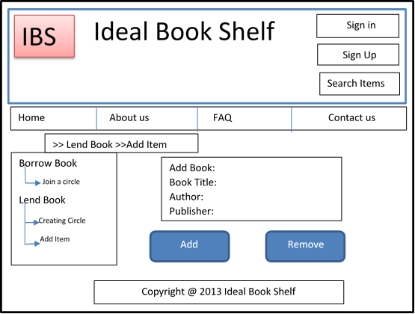

Add Book:

Book Title:

Author:

Publisher:

>> Lend Book >>Add Item

Add

Remove

The goal of user interface design is to make the user's interaction as simple and efficient as possible. It adds the satisfaction of the person using a product or service. The above webpage which using a different colours to attract user’s attention. User Interface includes usefulness, learnability, efficiency, and reliability and user friendliness.

For the Good website font size should be 8, 10 or 12 points with the serif and sans serif font types. Here In our website we used Times New roman for the name of the website, and Arial for the navigation .for the text and buttons we used times new roman and 12 points fonts ,which are serif fonts type and which are easy to understand for the user.

# 9. Three Tyre layers model -for the Architecture design

1. Application Layer- for the user interface
2. Middle Layer -for logic to use
3. Database Layer- for storage the data

User Computer

Application Tier

User interact with an application

R

Web and Application server

Presentation tier and data tier communicate with each other

Middle Tier

Database Server

Store data

Data Tier

# 

# References

(Ambler, 2003-2012; Bell, 2004)(UML Use Case Diagrams: Tips and FAQ)

Ambler, S. W. (2003-2012). *UML 2 Sequence Diagrams*. Retrieved from http://www.agilemodeling.com/artifacts/sequenceDiagram.htm

Bailey, B. (2002, February). *Human Factors International*. Retrieved from UI Design Newsletter: http://www.humanfactors.com/downloads/feb02.asp#kath

Bell, D. (2004, September 15). *UML basics: The class diagram*. Retrieved from IBM: http://www.ibm.com/developerworks/rational/library/content/RationalEdge/sep04/bell/

sparx systems. (n.d.). *UML 2 Sequence Diagram*. Retrieved from http://www.sparxsystems.com.au/resources/uml2_tutorial/uml2_sequencediagram.html

*UML Use Case Diagrams: Tips and FAQ*. (n.d.). Retrieved from http://www.andrew.cmu.edu/course/90-754/umlucdfaq.html